**Resume** 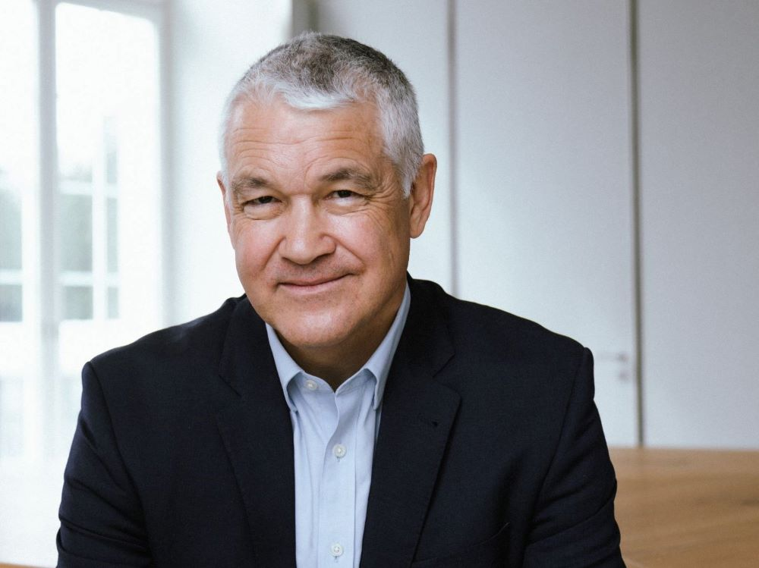

**Mike Mitchell**

**Principal: Squared – The Power of Two**

**“A seasoned global leader with a track record of developing teams and business”**

Key Strengths

* 36 years of (re)insurance and leadership experience.
* Career based on innovation and building profitable businesses.
* Developing and managing senior client / broker relationships.
* Excellent analytical and communication skills.
* Strong strategic vision, understanding of (re)insurance markets.
* Demonstrated leadership of cross cultural and functional teams in multiple locations.
* People development & cultural change.
* Technical ability with a strong commercial, outcomes driven mindset.
* Financial acumen – capital management, reserving.
* Significant networks in the (re)insurance community.
* Energised approach with a focus on execution.
* Excellent skills in strategy development, and proven ability to translate this into results.
* Flexibility, agility, and quick learner

Career History

Swiss Reinsurance Co. Zurich - Head of Property and Specialty Underwriting (2017-2023)

* Lead Property & Specialty underwriting, and Property & Casualty Centre – c 500 FTE
* Underwrite portfolio of P&S Reinsurance – c. $15bn premium $2bn underwriting margin.
* Reinsurance Executive Committee
* Risk & Finance Committee / Reinsurance Origination Committee
* Group Underwriting Committee
* Group Credit Portfolio Steering Committee
* Group Sustainability Council.

M&G Re London – Client Management and Underwriting (1987-1993)

* Strong grounding in reinsurance basics in a Head Office environment – smaller agile company with high technical capability.

M&G Re Singapore – Manager – Asia region (1993 – 1997)

* P&L responsibility for M&G Property & Casualty Asia business.
* Underwriting experience of all lines of business, including Casualty and most specialty lines.

Swiss Re Singapore – Manager – Property Treaty (1997 – 2001)

* Development of South East Asia property underwriting team.
* Lead complex claims and re-underwriting process around Jakarta riots.
* Member of regional actuarial services team – Asia.

Swiss Re Melbourne – BU Manager (2001 – 2004) (Plus Head UW P&C 2003 -)

* Transformational leadership of Business Unit.
* Business growth, driving major strategic relationships.
* P&L for P&C treaty and facultative business in Australian Southern region.

Swiss Re Sydney – Head UW ANZ (2004 – 2006)

* UW leadership of Australia & New Zealand business, Treaty and Fac, Property & Casualty
* Property treaty cat book growth – multiples of 2004 size by 2010 - 25% market share.

Swiss Re Asia - Property Head (2006 – 2017)

* Property product lead Asia – strong organic growth & innovations.
* Member Asia Management Team, Property Specialty global Executive Team.
* Frequent market commentator in press, conferences, and industry forums.
* 2011 Japan and ANZ Catastrophe response.

Swiss Re – Head of Structured Reinsurance Solutions (2013 – 2015)

* Lead global team of transactions specialists.
* Complex solutions for capital and volatility management.
* Significant outperformance of stretching targets.

Swiss Re Asia – Head of Property & Casualty Fac (2015 – 2017)

* Developed regional strategy for Fac in Asia.
* Change management to lead team to focus on growing profits as main priority.

Education

* Secondary – St George's College, Weybridge, Surrey – UK (1984)
* Exeter University – UK – BA (hons) Economics & Politics II ii (1987)
* Associate of Chartered Insurance Institute – UK – (1990)
* Ongoing education with multiple Swiss Re internal programmes.

External Positions.

* Chair/Board member – Australian Nuclear Insurance Pool Pty. (2012-2017)
* Advisory Board Member – Risk Frontiers (Macquarie University (2008-2017)
* Australian Business and Climate Group. (2008-2015)

Key achievements.

* Built C-suite broker and client relationships.
* Lead the SR engagement with Lloyd's market.
* Grew Global Nat Cat business to cement leading market-share.
* Built a global specialty underwriting model – driving profitable growth
* Managed the P&C team through 2017-22 Cat frequency, Covid19 & Ukraine War.
* Orchestrated resources repositioning to grow offshore support.
* Culture shift programme for global P&C underwriting.
* Driving sustainability strategy within the SR Reinsurance business.